# Bicycle Repair Shop

The following represents a system in use in a bicycle repair shop. When a customer brings in their bike to be repaired, the **receptionist** records their **name** and **contact** **number**. ­­The **serial** **number** of the **bike** (this is unique for each bike) and the **model** of the **bike** are recorded by the **shop** **assistant**. The bike is given an initial **status** **of ‘R’**, for ‘repair’. A **repair** **number** is **generated** and given to the customer, for reference.

When a new model of bike is manufactured, suppliers send each bicycle shop a list of the model number and the model name. They also get a list of parts that are used in each bike model. Parts can sometimes contain other parts – for example, the wheel will contain spokes, but a spoke can be provided separately. The owner records new models, new suppliers, new parts and which parts go in which models.

In the workshop, a mechanic, who is ready to do a repair, looks up the database to see which bikes are awaiting repair. The mechanic picks a bike, looks at the description of the repair required and then carries out one or more tasks on that bike. Some of the tasks may require replacement or additional parts, and some may be labour, such as servicing the bike. When the mechanic has finished, he / she records any parts that have been replaced in the bike, and the number of hours labour that were spent on the bike. The status of the bike is then changed to ‘C’ for ‘collect’.

The customer has been given a reference number, and may look up the shop’s web site to track the repair. To check to see if the bike is repaired the customer can type in the reference number. The customer will then receive a message saying that either the bike is awaiting repair, awaiting collection, or doesn’t exist.

In addition to that, the receptionist rings each customer who has a bike in the repair shop awaiting collection. When the bike is collected and paid for, the receptionist changes the status of the bike to ‘F’ for ‘finished’. The repair information stays on the system for a month and is then deleted by an automated task.

Design and implement a database to hold and manipulate this data.

Roles: Receptionist: Tony

Customer Table

ShopAssistant: Tony

CustomerBike Table

Owner: DJ

ModelBike Table

BikeParts Table

Suppliers Table

Mechanic: Aaron

CustomerBike

Customer: Aaron

Access to CustomerBike to check progress

Tables: Customer, CustomerBike, ModelBike, BikeParts, Suppliers

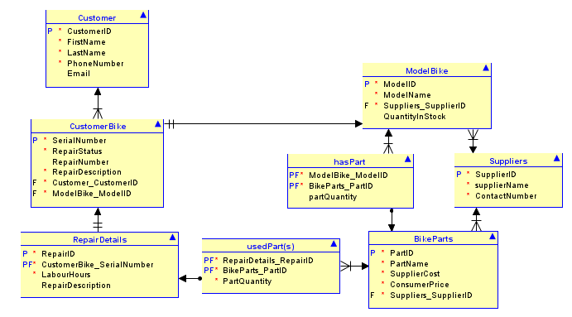

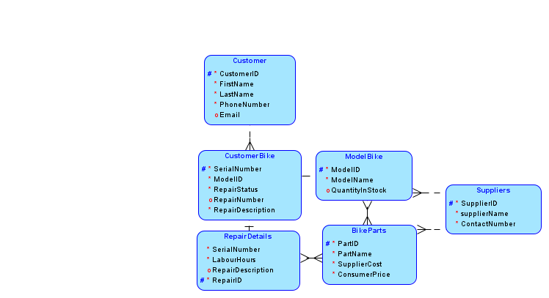

We got together at my house and brainstormed through the logical side of the database on oracle database modeler once the logical side was completed, we used the engineering tool in oracle to create the relational model. Once this was done, we finished editing the relational model to be accurate to our idea of how the database should run. Finally, we used the tools in oracle to generate SQL code to create the database and once it was converted to PostgreSQL code created the database on our own machines to begin the solo portion of the project.